Batique Techniques
Muffy Clark Gill

Supply list

Instructor provided supplies:
Professional wax brush, 1 Japanese dye brush, stencil materials, Tjaps, soy/beeswax and Japanese Kimono dyes. (An additional Tjanting may be purchased for $6.00) Posterboard for stencil cutting. A multi-page handout showing the techniques we will be using, wax pans and clothes pins.
A check for $60 to cover supplies provided by instructor should be made out to Funky Flamingo Studio

Student Required Supplies:
- Push pins-plastic or stainless steel
- Rubber gloves
- 1 large water container (clean large yogurt container)
- 4-6 small glass jars (baby food jars are ideal if you can find them)-you can get in the dollar store
- A few sheets of tracing paper
- 16x 20 “wooden stretcher bars or commercial system for stretching fabric (May bring a second stretcher if you know you want to do a lot of work)
- Any Japanese wax or dye brushes or Indonesian wax tools if you own
- Pencil, eraser, and sketchbook
- Some of your own designs and symbols for reference
- Scissors and Xacto knife with extra blades
- Masking tape
- Cutting surface (if you have one)
- 2-3 yds of white medium-weight (14mm+) 100% silk fabric, prewashed (Can use Dawn or Synthrapol). Please make sure they are ironed before use! Suitable silks are Crepe de Chine, Dupioni, Silk Broadcloth (Thai #19c), preferably 12mm or higher thread count.
- 2 small clean white towels (Dollar store or similar)
- A few clothes pins
- 2 cello sponges
- Roll of masking tape-blue type works best

Fabric sources are:
- Pro Chemical & Dye: https://prochemicalanddye.net
- Thai Silks www.thaisilks.com
- Dharma Trading: www.dharmatrading.com
- Test Fabrics http://testfabrics.com/product-detail.php?id=T0RNPQ==
- Nice small new wax heater: https://www.amazon.com/gp/aw/d/B08T982VVD?psc=1&ref=ppx_pop_mob_b_asin_title

Experience Level: All levels.
Questions?Muffy@muffyclarkgill.com

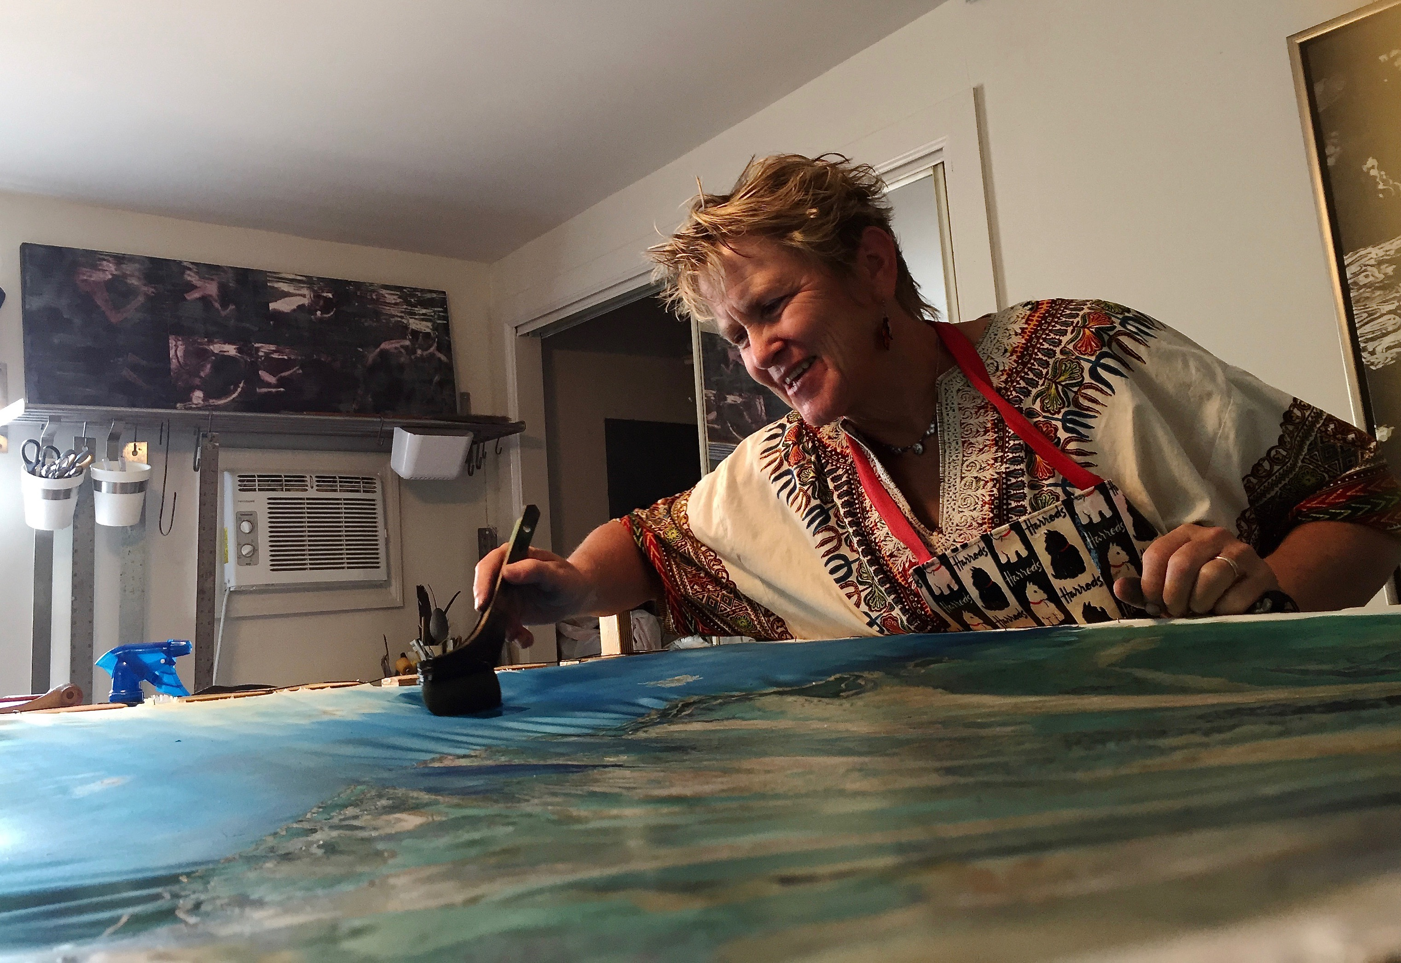
Muffy Clark Gill is an award-winning artist who has worked in the batik process for almost 40 years. She became acquainted with batik while visiting Kampala, Uganda as a teenager in high school. There she attended an art exposition featuring artwork created in Batik. Smitten with the process, she returned to the states to learn more about this ancient style of artwork. She has a BFA from Boston University in Graphic Design, and has taken workshops with well-known instructors rozome artist Kiranada Sterling Benjamin, Rice paste resist and dying with artist John Marshall, indigo, Shibori, and paste resist printing in Japan with artist Bryan Whitehead, fiber techniques with artist Jane Dunnewold. Muffy will be having a solo exhibition in November-December, 2019 at the United Arts Council Gallery in Naples, Florida, followed by a join exhibition with photographer Jeff Ripple in January, 2020 at the Alliance for the Arts in Ft. Myers. She also had a solo exhibition in the 22nd Floor Florida State Capitol Gallery featuring her batik paintings of the Native Americans of south Florida in February 2015. Her work has also been on display in the “Florida Contemporary 2015”, at the Baker Museum of Art in Naples, Florida as well as the “2015 National Fiber Directions Exhibition” in Wichita, Kansas. She is a member of the National Association of Women Artists, a professional organization of artists nominated by their peers.

