Workshop Student Tool List

Students should bring:
- Throwing bats and pins (3-4 bats)
- Banding Wheel
- Sharp knife ( I use a Dolan 220c, but an Exacto or similar will work)
- Fettleing knife
- Soft Rib (I use a Red Kidney Mudtool, small and large)
- Scoring tool (Kemper SWB, scratch wire brush)
- Rolling pin
- Small container (for joining slip, small yogurt size)
- Spray bottle
- Soft nylon brush, long and short handles, for seam smoothing
- Various throwing ribs, metal and rubber
- Ruler

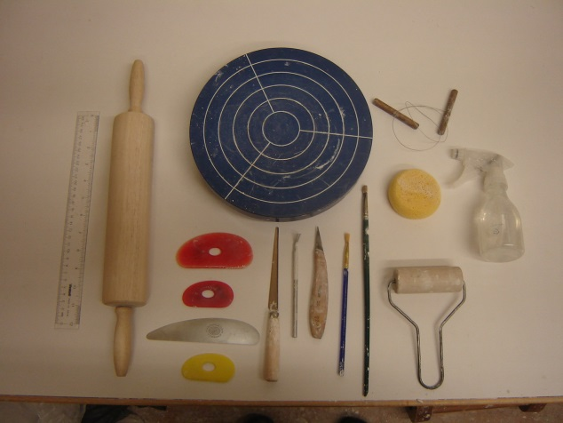

Image of my tools, for student reference.

